**Introduction (Explain using the below picture & then explain about J2EE):**

Start explaining about Gmail, Facebook & FlipCart application (how to access these applications, behaviour, functionality, and necessary steps involved, supportive tolls required like, internet, and browser)

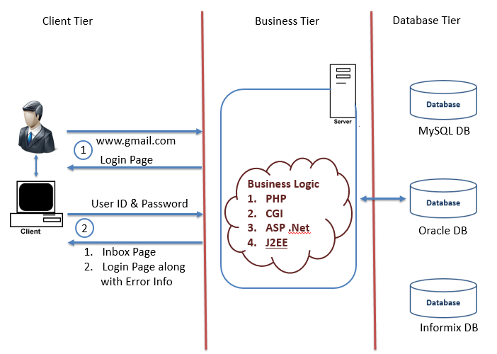

**Java 2 Enterprise Edition (J2EE / JEE)**

* J2EE is a collection of API’s which are Platform-Independent & Java-Centric, helps us to develop Enterprise Web Applications
* A web application is an application that is accessed over the network (Internet / Intranet) with the help of Web Browser
* An API is a collection of packages (one/more) which provides specific functionality. Major API’s of J2EE are

1. JDBC
2. Servlets
3. JSP

* JDBC helps us to interact with Data Base & Servlets / JPS’s helps us to accept the request over the network & generate the response

**Interview Question:** Validate the Statement : JDK is Platform Dependent ? Yes / No

**J2EE 3-Tier Architecture**

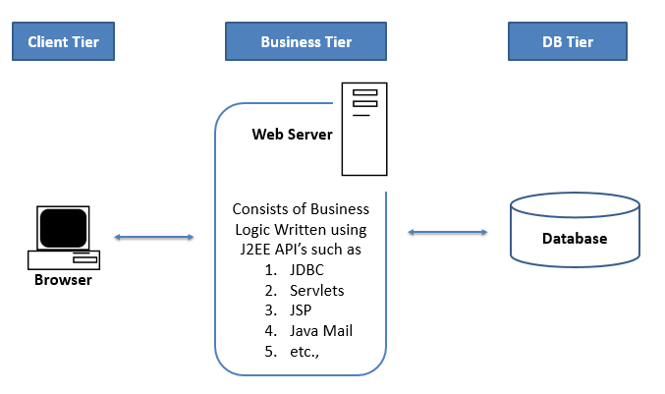

**J2EE Prerequisite:**

* Should have knowledge of Java (Mandatory / Must Have)
* Good to have SQL Knowledge (Need to Have)
* Good to have HTML knowledge (Need to Have)
* Good to have Eclipse IDE Knowledge (Good to Have)

JDBC Table of Contents

# Introduction

* About JDBC
* Advantages of JDBC
* JDBC Prerequisites

# Drivers

* Introduction
* About Driver Class
* How to Load the Driver Class into Program

# DB URL

# Connection Interface

* DriverManager Class
* getConnection() method
* Connection Object

# JDBC Statements

* Statement
* PreparedStatement
* CallableStatement

# ResultSet

# Transactions

Servlets Table of Contents

# Introduction

* About Web Browser
* About Web Sever
* Installation of Tomcat Webserver
* About Web Resources
* About Web Application

# Servlets

* Why Servlets
* Creating the First Servlet
* Build & Deployment Process
* WAR File

# Web URL

* Query String
* Protocol
* About HTTP & HTTPS
* Key Elements of HTTP Request & HTTP Response
* HTTP Methods
* Difference between GET & POST

# Servlet Container

* About Servlet Container & its advantages
* Request & Response Objects
* getParameter() & getParameterValues() Methods
* Web.xml

# Servlet Hierarchy

* GenericServlet
* HttpServlet
* Difference between GenericServlet & HttpServlet
* Servlet Lifecycle
* SingleThreadModel Servlets

# ServletContext & ServletConfig

# Redirect, Forward & Include

# Attributes

# Cookies

* Introduction
* Persistent & Non-Persistent Cookies

# Session

* Introduction
* Advantages of Session
* Steps to work with session
* URL Rewriting

# “StudentsApp” Web Application Development exercise

JSP Table of Contents

# Introduction

* About JSP
* Difference between Servlets & JSP

# JSP Lifecycle

# JSP Objects

* Objects Scope in JSP
* Implicit Objects

# JSP Tags

* Declaration Tag
* Expression Tag
* Scriptlet Tag
* Action Tag

1. Forward Action
2. Include Action
3. UseBean Action

* Directive Tag
  1. Include Directive
  2. TagLib Directive
  3. Page Directive

**5. Error Handling in JSP**

**6. Single Threaded JSP**

**7. Redirect in JSP**